Full Load:
Scenarios:
- How to copy multiple tables from azure SQL database to ADLS gen2.
- How to avoid running copy activity if table not available in source side
- How to create & maintain metadata table or Watermark or Control table
- 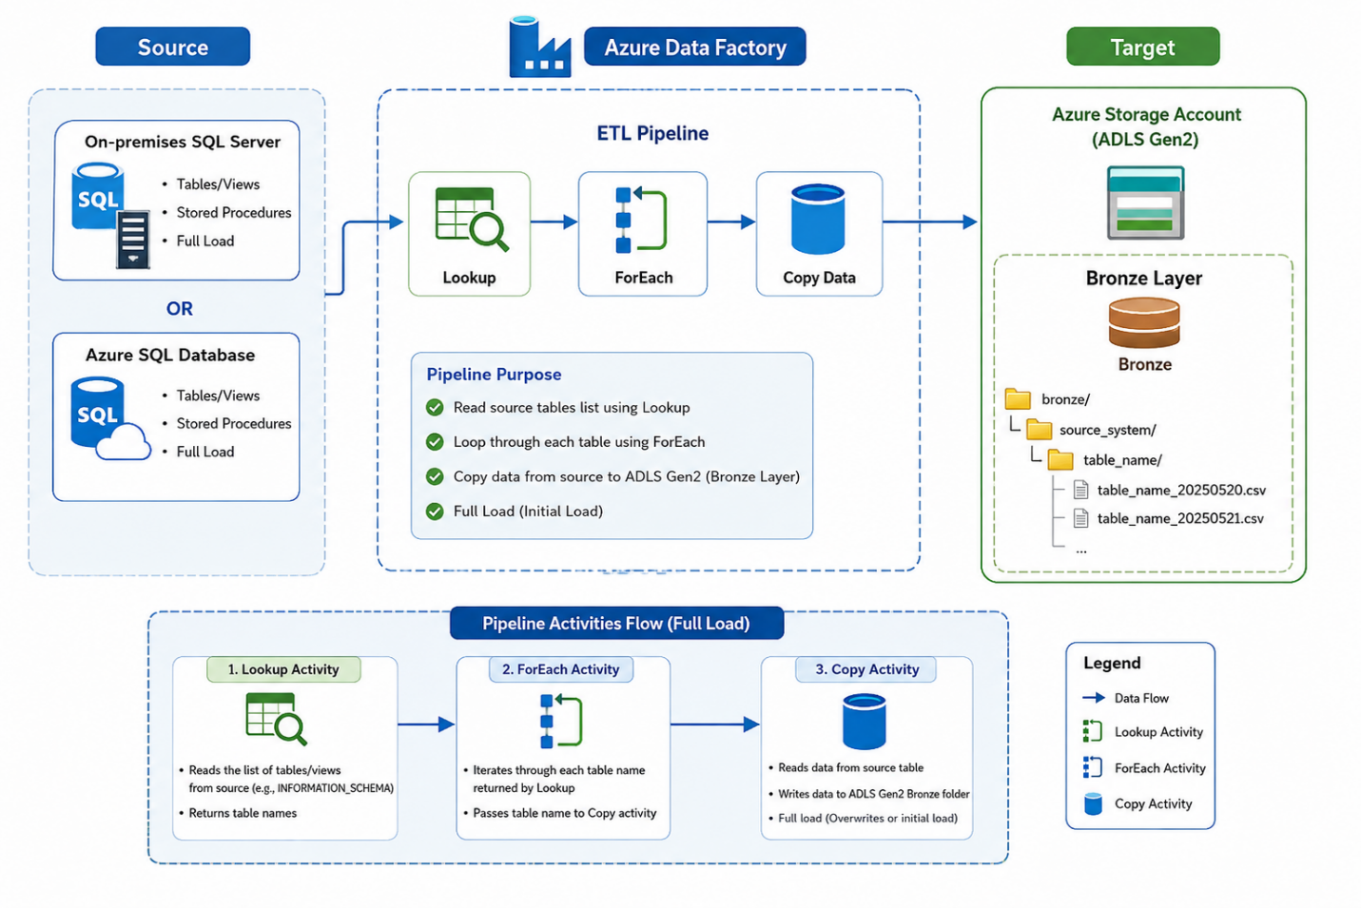

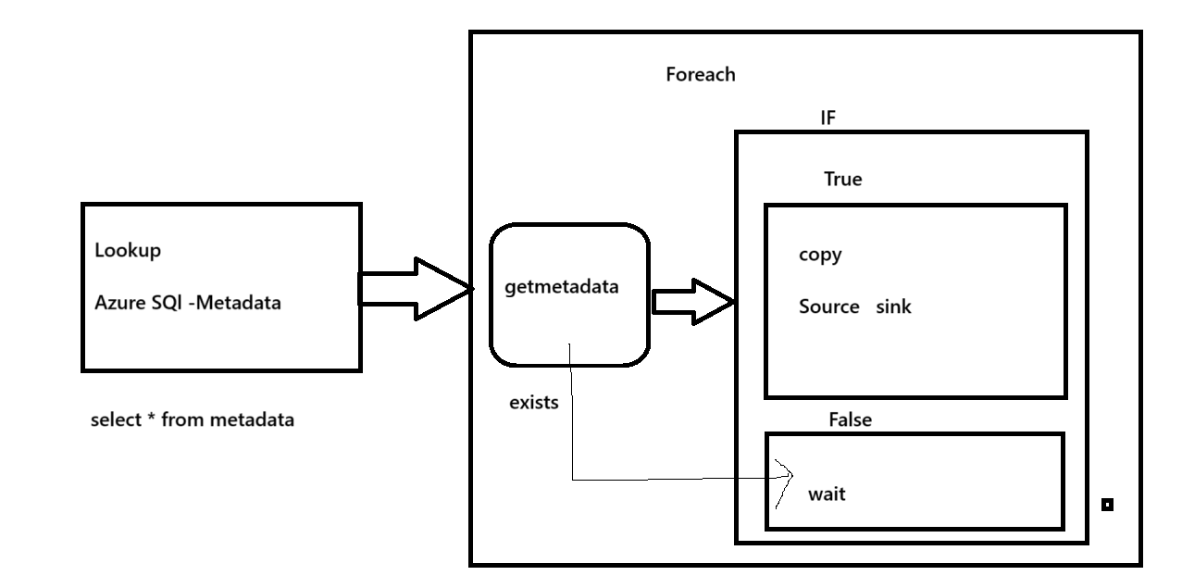

Estimations:
- Azure data factory
- Auto-Resolve IR or Azure IR
- 4 datasets
- 3 linked services(source, destination, keyvault)
- Pipeline
- Look up activity, Foreach activity (Get metadata activity, if activity (True (copy activity) or False (wait activity)))
- Azure SQL Server - Source
- Storage accounts – ADLSgen2 - Destination
- Key vault
Imp points:
1. In ADF- there is a relationship b/w previous activity and coming activity
2. previous activity producing some output , that ouput help to the coming activity as a input
3. Look up activity always talk about "value" manner
4. foreach activity always talk about "item" manner
5. sql server point of view talk about "record" manner
6. Data sets creations belongs to lookup, getmetadata, copy
7. Dataset parameters - For handling bulk of tables+ each and every table have the own schema name
and table name as well as I want to maintain my own nameing convention, once the data is succesfully
copied from azure sql to adlsgen2 under bronze container

7. Dont create dataset parameters for look up activity becoz purpose of lookup activity here to get

only metadata information

8. Dataset parameters applicable for getmetadta activity and copy activity
9. Copy activity ->if activity ->foreach activity
Lab:
Step1:
Sql scripts:
- Table creations
- create table product(pid int, pname varchar(50))
- create table sales (salesid int, storename varchar(50))
- create table transactions(tid int, tamount bigint)
- create table cust(cid int, clocation varchar(50))
- create table emp(empid int, empname varchar(50))
- Insert data into tables
- insert into product values(111,'Laptop'),(222,'Mobile')
- insert into sales values(1,'Flipkart'),(222,'amazon')
- insert into transactions values(101,1000),(202,2000)
- insert into cust values(1000,'Banglore'),(2000,'hyderabad')
- insert into emp values(888,'rama'),(999,'krishna')
- create table metadata(schemaname varchar(50),tablename varchar(50),
foldername varchar(50), isdisable int)
insert into metadata values('dbo','product','productoutput',0),
('dbo', 'sales','sellsoutput',0),
('dbo','transactions','transactionsoutput',0),
('dbo','cust','custoutput',0),
('dbo','emp','empoutput',0),
('dbo', 'orders', 'ordersoutput',1)
Step2:
Linked services:
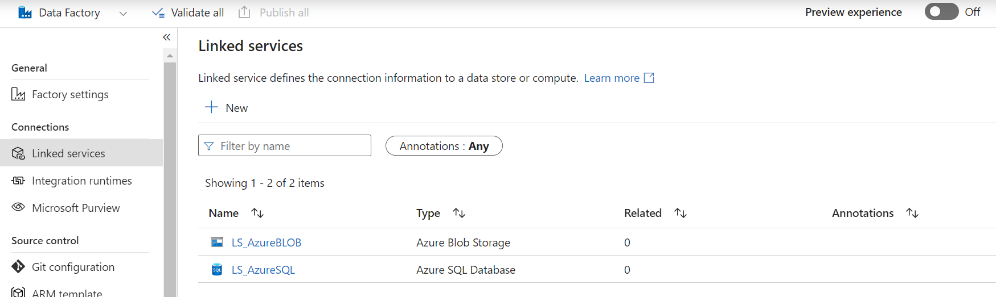
Datasets
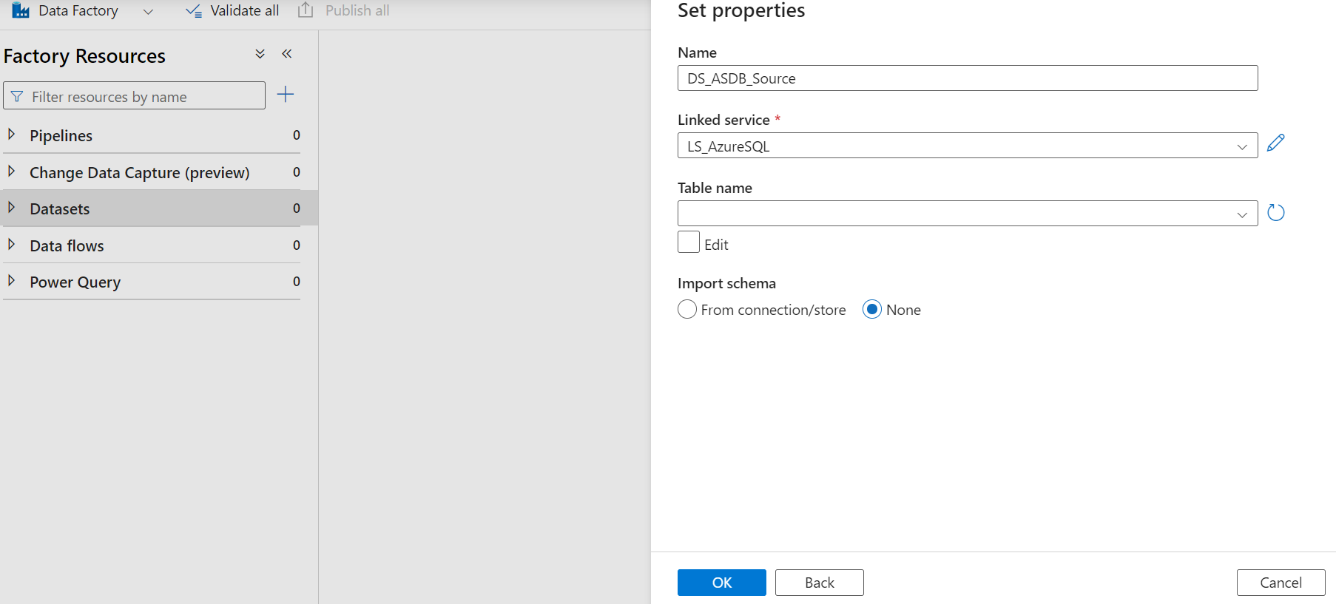
Lookup activity
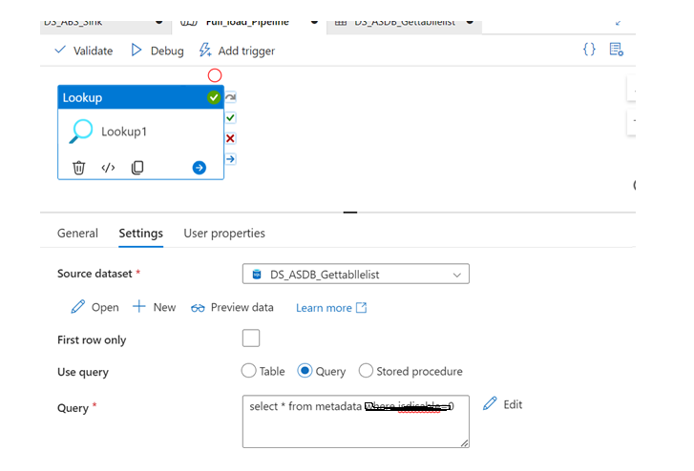
1.lookup
-dataset, no need to select any table
2. foreach
get metadata.
key: exist.
-dataset, no need to select any table
- Step1: create dataset parameters
- Step2: go to connection under dataset, click on table, click on enter manually,
double click on adds dynamic content.

- Step3: go to pipeline, click on get metadata activity, you will see dataset parameters
- we need to pass the values, but we are under foreach activity, always foreach understand
item only
- pass the dynamic expression for values
- give the lookup activity output left side values
Dataset parameters for get metadata activity.
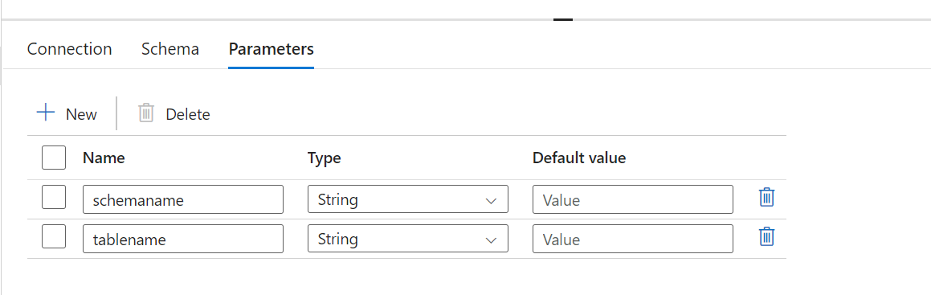
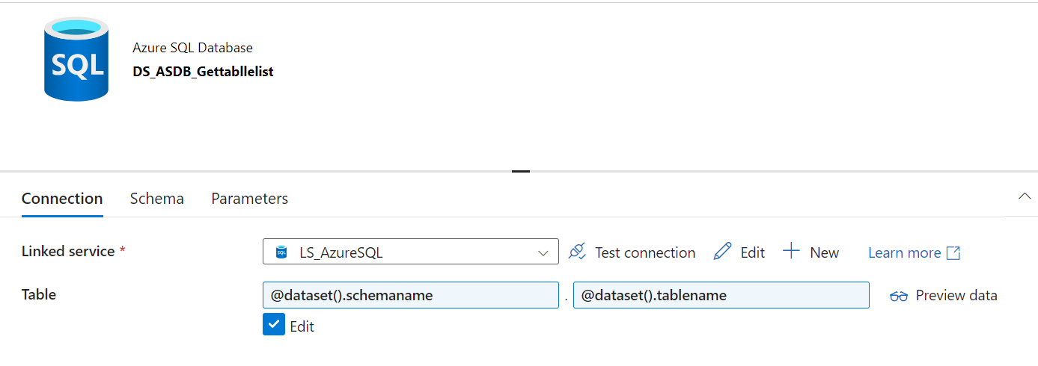
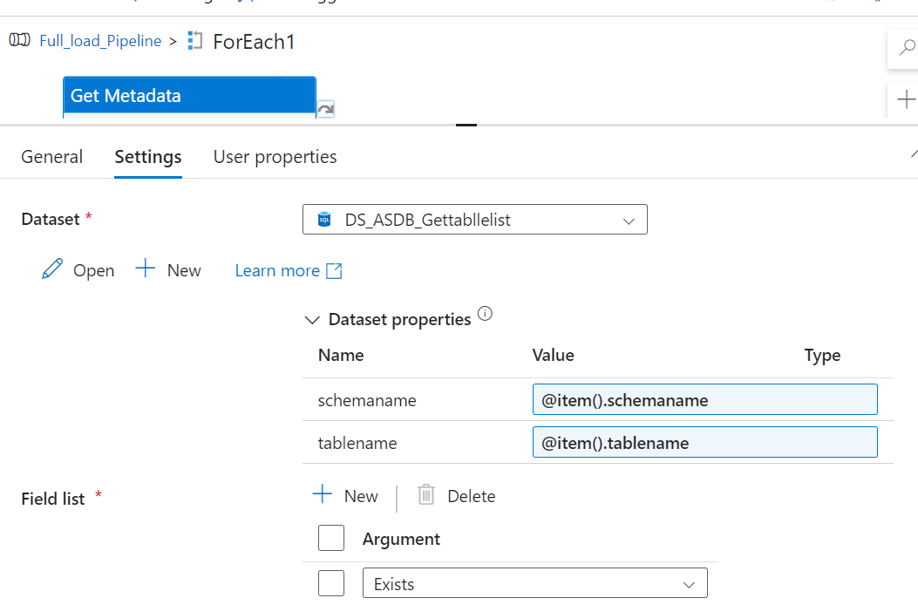

@equals(activity('Get Metadata1').output.exists,true)

Copy activity:
Source:
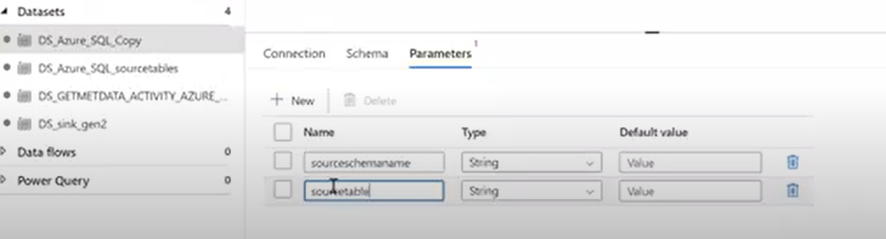
Sink: 